Module 06 [Data Structure with STL]

(for Week 7)
Topic 1 [STL: stack class]
Problem statement: Write a menu program to create and manipulate Stack using stack
class and perform the following operations using the specified method.
- use push() method to push data
- use pop() method to pop data
- use top() method to display top element
- use empty() method to check whether stack is empty or not
** Stack **
- Push
- Pop
- Display()
- Exit
Enter your option:
Code:
#include<bits/stdc++.h>
using namespace std;

int main(){
stack<int> st;
int opt, val;

while(true){
cout<<"\n1.Push\n2.Pop\n3.Top\n4.Check Empty\n5.Exit\n";
cin>>opt;

switch(opt){
case 1:
cout<<"Enter value: ";
cin>>val;
st.push(val);
break;

case 2:
if(!st.empty()){
cout<<"Popped: "<<st.top()<<endl;
st.pop();
} else cout<<"Stack Empty\n";
break;

case 3:
if(!st.empty())
cout<<"Top: "<<st.top()<<endl;
else cout<<"Stack Empty\n";
break;

case 4:
cout<<(st.empty()?"Empty":"Not Empty")<<endl;
break;

case 5:
return 0;
}
}
}

Topic 2 [STL: queue class]
Problem statement: Write a menu program to create and manipulate Queue using
queue class. Perform the following operations using the specified method.
- use push() method to enqueue data
- use pop() method to dequeue data
- use front() method to display front element
- use back() method to display rear element
- use empty() method to check whether queue is empty or not
** Queue **
- Enqueue
- Dequeue
- Display Front
- Display Rear
- Exit
Enter your option:
Code:
#include<bits/stdc++.h>
using namespace std;

int main(){
queue<int> q;
int opt, val;

while(true){
cout<<"\n1.Enqueue\n2.Dequeue\n3.Front\n4.Rear\n5.Exit\n";
cin>>opt;

switch(opt){
case 1:
cin>>val;
q.push(val);
break;

case 2:
if(!q.empty()){
cout<<"Removed: "<<q.front()<<endl;
q.pop();
} else cout<<"Queue Empty\n";
break;

case 3:
if(!q.empty())
cout<<"Front: "<<q.front()<<endl;
break;

case 4:
if(!q.empty())
cout<<"Rear: "<<q.back()<<endl;
break;

case 5:
return 0;
}
}
}

Topic 3 [STL: vector class]
Problem statement: Write a menu program to create and manipulate linked list using
vector class and use the following methods
- push_back()
- push_front()
- begin()
- end()

- pop_back()
- pop_front()
- insert()
- erase()
** Linked List **
- Insert
- Delete
- Update
- Search
- Exit
Enter your option:
Code:
#include<bits/stdc++.h>
using namespace std;

int main(){
vector<int> v;
int opt, val, pos;

while(true){
cout<<"\n1.Insert\n2.Delete\n3.Update\n4.Search\n5.Exit\n";
cin>>opt;

switch(opt){
case 1:
cin>>val;
v.push_back(val);
break;

case 2:
cin>>pos;
if(pos>=0 && pos<v.size())
v.erase(v.begin()+pos);
break;

case 3:
cin>>pos>>val;
if(pos>=0 && pos<v.size())
v[pos]=val;
break;

case 4:
cin>>val;
for(int i=0;i<v.size();i++)
if(v[i]==val)
cout<<"Found at "<<i<<endl;
break;

case 5:
return 0;
}
}
}

Topic 3.1 [STL: vector class]: Add more feature to the menu of Topic 3.

Module 07 [UML+Java Basics]

(for Week 8: 19-23/7/2025)
Topic 1 [UML]
Problem statement: Draw the UML diagram for the following class
class Test{ private: int x; protected: int y; public: int z; public:
void SetData(int a,int b,int c){ x=a;y=b;z=c;
}
float getAverage(){ Return (x+y+z)/3.0;
}
Code:
-------------------------
| Test |
-------------------------
| - x : int |
| # y : int |
| + z : int |
-------------------------
| + SetData(a:int, |
| b:int, |
| c:int) |
| + getAverage():float |

Topic 2 [UML: Aggregation]
Problem statement: Create two classes Doctor and Patient to store the information of doctors and patients respectively. Now write codes to create association between these two classes by aggregation.
[note: if Patient class is destroyed then Doctor class is still exist]
class Doctor{  //write your code  } | class Patient{  //write your code  } | int main(){  //write your code  }
Code:
#include<bits/stdc++.h>
using namespace std;
class Student
{
public:
str#include<bits/stdc++.h>
using namespace std;

class Patient{
public:
string name;
Patient(string n){ name = n; }
};

class Doctor{
public:
Patient* p; // aggregation (reference)

Doctor(Patient* p){
this->p = p;
}

void show(){
cout<<"Patient: "<<p->name<<endl;
}
};

int main(){
Patient p("Ragib");
Doctor d(&p);

d.show();
}ing name;
Student(string n)
{
name = n;
}
};

Topic 3 [UML: Composition]
Problem statement: Create two classes Doctor and Patient to store the information of doctors and patients respectively. Now write codes to create association between these two classes by composition.
[note: if Doctor class is destroyed then Patient class is also destroyed]
class Doctor{  //write your code  } | class Patient{  //write your code  } | int main(){  //write your code  }
Code:
#include<bits/stdc++.h>
using namespace std;

class Patient{
public:
string name;
Patient(string n){ name=n; }
};

class Doctor{
public:
Patient p; // composition

Doctor(string name): p(name){}

void show(){
cout<<"Patient: "<<p.name<<endl;
}
};

int main(){
Doctor d("Ragib");
d.show();
}

Topic 4: [java Programming Basics]
Problem Statement: Write java programs to do the following
  - Display your name and address in two lines
  - Take two integers as inputs and prints the bigger one
  - Input a series of 10 numbers into an array ax[] and finds the largest, smallest and average of these numbers. Also write code for searching and sorting.
Code(i):
class A{
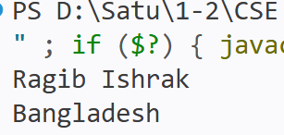
public static void main(String[] args){
System.out.println("Ragib Ishrak");
System.out.println("Bangladesh");
}
}
Code(ii):
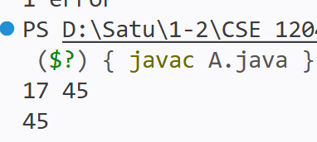
import java.util.*;
class A{
public static void main(String[] args){
Scanner sc=new Scanner(System.in);
int a=sc.nextInt(), b=sc.nextInt();
System.out.println(Math.max(a,b));
}
}
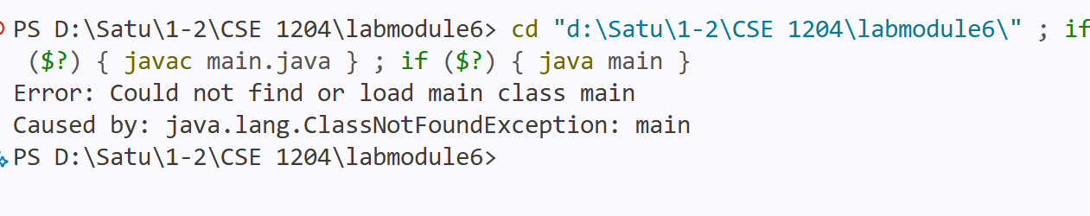
Code(iii): import java.util.*;
class A{
public static void main(String[] args){
Scanner sc=new Scanner(System.in);
int a=sc.nextInt(), b=sc.nextInt();
System.out.println(Math.max(a,b));
}
}

Topic 5 [java Programming private method]
Problem Statement: Verify that private methods can be used only inside the class but it cannot be used from outside the class.

Code:
class A{
private void show(){
System.out.println("Private method");
}

void call(){
show(); // allowed
}

public static void main(String[] args){
A obj=new A();
obj.call();
// obj.show(); ❌ not allowed
}
}

Topic 6 [java Programming static method/member]
Problem Statement: Verify that static methods can access static method/member but cannot access to non-static method/member.
Code:
class A{
static int x=10;
int y=20;

static void show(){
System.out.println(x); // allowed
// System.out.println(y); ❌ not allowed
}

public static void main(String[] args){
show();
}
}

Topic 7 [java Programming]
Problem Statement: Write a Java Program to initialize radius of a circle using constructor/Setter and calculate area of the circle.

Code:
class Circle{
double r;

Circle(double r){
this.r=r;
}

double area(){
return Math.PI*r*r;
}

public static void main(String[] args){
Circle c=new Circle(5);
System.out.println("Area="+c.area());
}
}

